NETWORK INFRASTRUCTURE PROJECT

PANORAMA HOTEL NETWORK INFRASTRUCTURE

Group Number:

Team Members
Mohamed Ali Elsaeid  ID: 272552 | LinkedIn
Omar Wael Abdelsamie Kotb  ID: 322346 | LinkedIn
Amira Adel Mahmoud  ID: 327994 | LinkedIn
Mohamed Salama Elgebaly  ID: 335316 | LinkedIn
Youssef Sherif Abd Elazim Arafat  ID: 330595 | LinkedIn

Supervisor
Dr. Aya Magdy
Assistant Lecturer,
Faculty of Computers and Information

Table of Contents
1. Project Overview
2. Project Objectives
3. Team Members & Responsibilities
4. Network Topology
5. IP Addressing
6. Routing
7. Network Security
8. VLANs & Inter-VLAN Routing
9. Network Services
10. EtherChannel
11. HSRP
12. WLAN
13. PAT
14. Testing
15. Conclusion
16. Appendix

1. Project Overview
Panorama Hotel operates a network environment that serves hotel departments, shared services, wired endpoints, wireless users, and Internet-bound traffic. The Cisco Packet Tracer project models a complete multi-layer network in which access switching, Layer-3 switching, routing, redundancy, network services, security controls, wireless access, and edge translation work together as one infrastructure.
The saved Packet Tracer file contains 57 devices and 54 physical links: four Cisco 2960 access switches, five Cisco 3650 multilayer-switch models, two ISR4331 routers, centralized DHCP/DNS/HTTP servers, wireless access points, and end devices. Four of the 3650 switches perform Layer-3 routing, while D-SW3 / SW-L3-5 acts as Layer-2 service aggregation on 192.168.120.0/24. The design combines VLAN segmentation, HSRP, OSPF area 0, LACP EtherChannel, WLAN access, SSH-oriented management controls, and PAT (NAT overload) at the edge.

2. Project Objectives
- Segment hotel departments into VLANs and route between them through multilayer switching.
- Provide gateway redundancy with HSRP and internal path learning with OSPF area 0.
- Centralize DHCP, DNS, and HTTP services and relay DHCP requests from routed VLANs.
- Use LACP EtherChannel and trunks to carry VLAN traffic with link redundancy.
- Support wired and wireless clients while keeping a consistent IP addressing and gateway scheme.
- Use configured SSH/login protections for management and PAT so private hosts can share one outside IPv4 address.

3. Team Members & Responsibilities
Student Name | ID | Primary Responsibility | GitHub Username
Mohamed Ali Elsaeid | 272552 | Security | https://github.com/mohamedali206800-hub
Omar Wael Abdelsamie Kotb | 322346 | Documentation & Presentation
Amira Adel Mahmoud | 327994 | All Topology
Mohamed Salama Elgebaly | 335316 | …………………………….
Youssef Sherif Abd Elazim Arafat | 330595 | All Topology & Excel | https://github.com/yousef-sherif-arafa/CCNA-Panorama-Hotel-Project

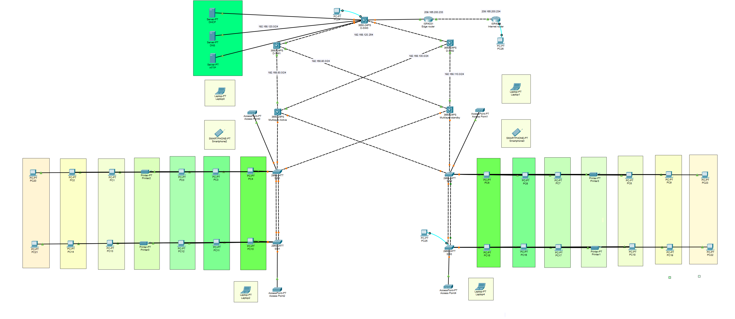
4. Network Topology

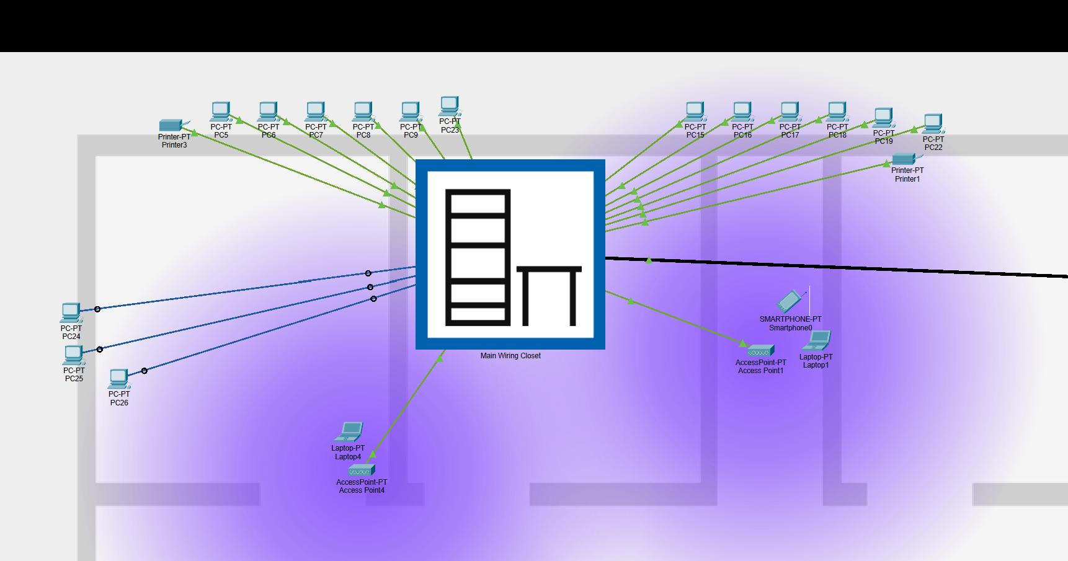

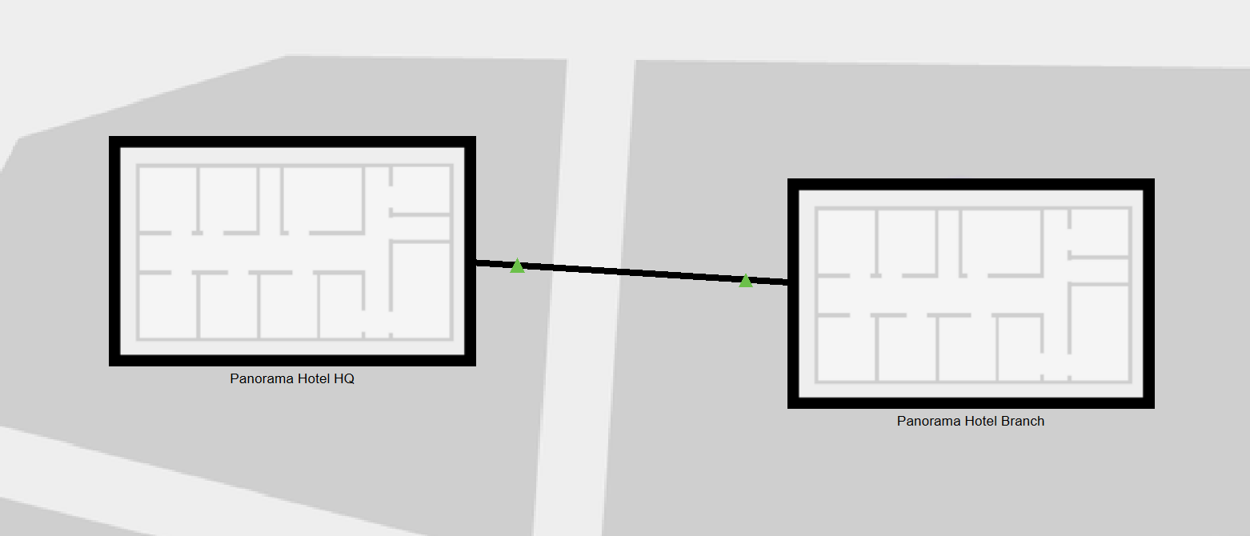
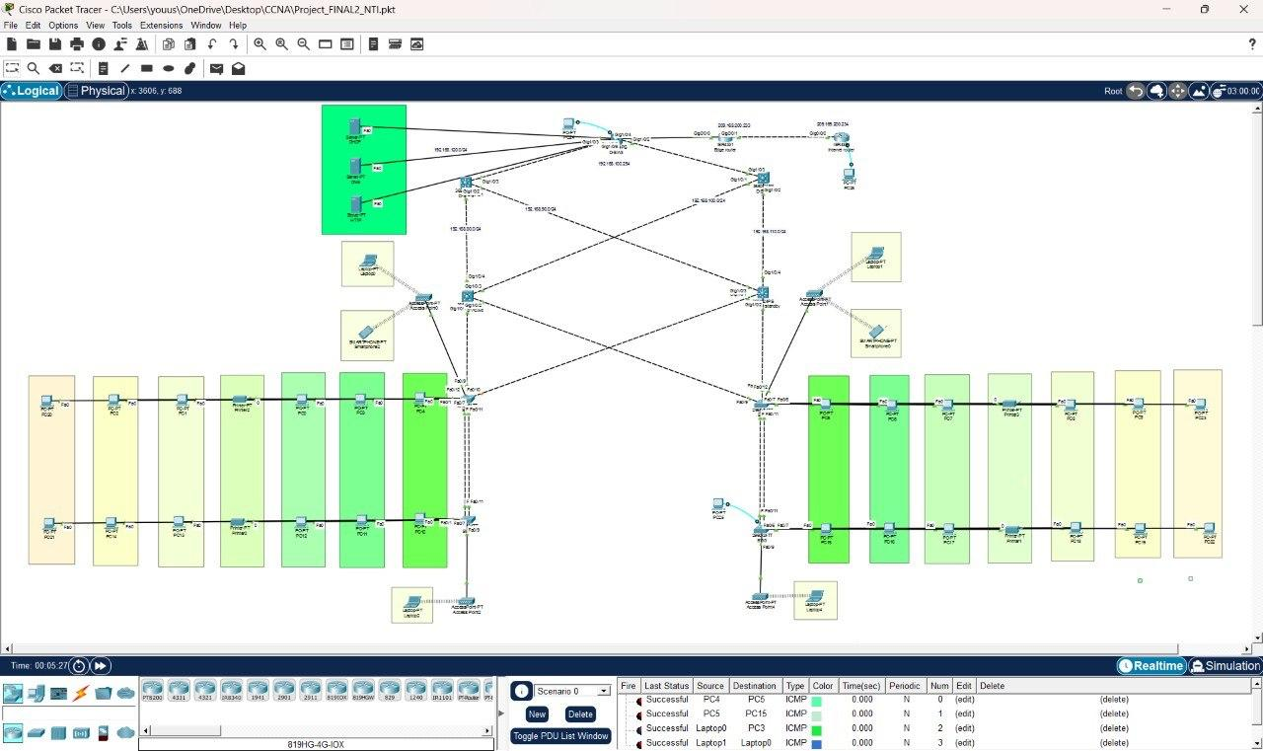

5. IP Addressing
The project uses a role-based classless IPv4 addressing plan. Internal user, transit, and service networks are standardized as /24 subnets, while the external point-to-point router link uses /30. The repeated /24 format makes the address plan easy to read because the third octet identifies the VLAN or routed segment, while the /30 on the edge link avoids wasting addresses where only two router interfaces are required.
Design rationale: A /24 leaves 8 host bits, so it provides 2^8 - 2 = 254 usable host addresses. This is more than the current device count in each VLAN, but it provides growth space and keeps the scheme simple. A /30 leaves 2 host bits and provides 2^2 - 2 = 2 usable addresses, which is ideal for the two-router WAN link. The trade-off of the /24 approach is unused address space in small VLANs.
Network / VLAN | Required Hosts | Network Address | Prefix | Usable Range | Broadcast
VLAN 1 - Wireless | 6 current clients | 192.168.1.0 | /24 | 192.168.1.1 - 192.168.1.254 | 192.168.1.255
VLAN 5 - Reserved/Infrastructure | 0 current access clients | 192.168.5.0 | /24 | 192.168.5.1 - 192.168.5.254 | 192.168.5.255
VLAN 10 - Reception | 4 current wired hosts | 192.168.10.0 | /24 | 192.168.10.1 - 192.168.10.254 | 192.168.10.255
VLAN 20 - Accounts | 4 current wired hosts | 192.168.20.0 | /24 | 192.168.20.1 - 192.168.20.254 | 192.168.20.255
VLAN 30 - HR | 4 current wired hosts | 192.168.30.0 | /24 | 192.168.30.1 - 192.168.30.254 | 192.168.30.255
VLAN 40 - Sales & Marketing | 4 current wired hosts | 192.168.40.0 | /24 | 192.168.40.1 - 192.168.40.254 | 192.168.40.255
VLAN 50 - IT | 4 current wired hosts | 192.168.50.0 | /24 | 192.168.50.1 - 192.168.50.254 | 192.168.50.255
VLAN 60 - Management | 4 current wired hosts | 192.168.60.0 | /24 | 192.168.60.1 - 192.168.60.254 | 192.168.60.255
VLAN 70 - Printers | 4 printers | 192.168.70.0 | /24 | 192.168.70.1 - 192.168.70.254 | 192.168.70.255
Transit A | 2 routed endpoints | 192.168.80.0 | /24 | 192.168.80.1 - 192.168.80.254 | 192.168.80.255
Transit B | 2 routed endpoints | 192.168.90.0 | /24 | 192.168.90.1 - 192.168.90.254 | 192.168.90.255
Transit C | 2 routed endpoints | 192.168.100.0 | /24 | 192.168.100.1 - 192.168.100.254 | 192.168.100.255
Transit D | 2 routed endpoints | 192.168.110.0 | /24 | 192.168.110.1 - 192.168.110.254 | 192.168.110.255
Server / Edge | 6 addressed infrastructure hosts | 192.168.120.0 | /24 | 192.168.120.1 - 192.168.120.254 | 192.168.120.255
WAN link | 2 router interfaces | 209.165.200.232 | /30 | 209.165.200.233 - 209.165.200.234 | 209.165.200.235

Gateway addressing pattern: SW-L3-1 uses .1 on user VLANs, SW-L3-2 uses .10, and the HSRP virtual default gateway is .254. On 192.168.120.0/24, RTR-1 uses .1, DHCP .2, DNS .3, HTTP .4, SW-L3-3 .5, SW-L3-4 .6, and the HSRP virtual address is .254.
Transit-link pattern: 192.168.80.1/24 (SW-L3-1) connects to 192.168.80.2/24 (SW-L3-3); 192.168.90.1/24 (SW-L3-2) connects to 192.168.90.2/24 (SW-L3-3); 192.168.100.1/24 (SW-L3-1) connects to 192.168.100.2/24 (SW-L3-4); and 192.168.110.1/24 (SW-L3-2) connects to 192.168.110.2/24 (SW-L3-4).

6. Routing

6.1 Routing Design
The internal network uses OSPF process 1 in a single backbone area (area 0). OSPF runs on SW-L3-1, SW-L3-2, SW-L3-3, SW-L3-4, and RTR-1. The edge uses a static default route toward RTR-2, and RTR-1 advertises that default route into OSPF using default-information originate. RTR-2 represents the simulated external/Internet side and uses a static route back toward RTR-1.
Design rationale: OSPF was selected for the internal routed topology because it automatically exchanges routes, adapts when routed paths change, and avoids maintaining many device-by-device static routes. A single area 0 is appropriate for this project size because it keeps the design simple while still demonstrating dynamic routing and redundant paths. The default route remains static at the edge because the topology has only one external next hop.
Device | Routing Method | Networks / Route | Role
SW-L3-1 | OSPF 1 / area 0 | VLANs 1, 5, 10-70; 192.168.80.0/24; 192.168.100.0/24 | Primary user-gateway side + two routed uplinks
SW-L3-2 | OSPF 1 / area 0 | VLANs 1, 5, 10-70; 192.168.90.0/24; 192.168.110.0/24 | Redundant user-gateway side + two routed uplinks
SW-L3-3 | OSPF 1 / area 0 | 192.168.80.0/24; 192.168.90.0/24; 192.168.120.0/24 | Aggregates two internal routed paths toward services
SW-L3-4 | OSPF 1 / area 0 | 192.168.100.0/24; 192.168.110.0/24; 192.168.120.0/24 | Second routed path toward services
RTR-1 | OSPF 1 + static default | 192.168.120.0/24; default via 209.165.200.234 | Internal/external boundary; injects default route
RTR-2 | Static routing only | Default route via 209.165.200.233 | Simulated Internet-side router
D-SW3 / SW-L3-5 | Layer 2 only | No OSPF networks | Bridges devices on the 192.168.120.0/24 service segment

Why D-SW3 does not run OSPF: although it is a multilayer-switch model, the saved configuration uses it as a Layer-2 aggregation switch. The Layer-3 interfaces for the service segment are on RTR-1, SW-L3-3, and SW-L3-4, so D-SW3 only forwards Ethernet frames between those devices and the servers.

6.2 Configuration
The /24 OSPF networks use wildcard mask 0.0.0.255. The following snippets represent the saved design:
Example - SW-L3-1:
router ospf 1
network 192.168.80.0 0.0.0.255 area 0
network 192.168.100.0 0.0.0.255 area 0
network 192.168.10.0 0.0.0.255 area 0
... additional connected user VLAN networks ...

Edge routing - RTR-1:
ip route 0.0.0.0 0.0.0.0 209.165.200.234
router ospf 1
network 192.168.120.0 0.0.0.255 area 0
default-information originate

The static default route gives RTR-1 a route for destinations that are not in the internal routing table. default-information originate then advertises a default route to internal OSPF neighbors, so internal devices do not need a separate static Internet route.

6.3 Verification
Use show ip ospf neighbor to confirm adjacency, show ip route to confirm connected/OSPF/default routes, show ip protocols to confirm OSPF process 1 and advertised networks, and ping/traceroute between user VLANs and the 192.168.120.0/24 service segment. The expected result is that OSPF-learned routes appear with code O and internal devices have a default path toward RTR-1.

7. Network Security
The project uses SSH for remote management of the routers and switches. SSH encrypts the management session, allowing administrators to access device commands without sending the session as plain text.
Basic device configuration is also applied, including device hostnames, an enable secret, passwords for local access, password encryption, and an MOTD banner. These settings help identify devices and restrict access to their configuration. This section describes the management settings used in the project; it does not claim that additional security features, such as departmental ACLs, port security, or a firewall, were implemented.
The configured settings can be checked on each device using show running-config. SSH access should be demonstrated with a successful login from another device in Packet Tracer.

8. VLANs & Inter-VLAN Routing
Document VLAN IDs, project roles, assigned ports, trunk links, and Inter-VLAN Routing.
VLAN segmentation separates departmental Layer-2 broadcast domains while keeping the same physical switching infrastructure. The project role mapping is shown below. VLAN 5 exists as an infrastructure/reserved SVI in the saved Layer-3 configuration, while the user-facing access ports are assigned to VLANs 10-70.
VLAN | Project Role | Access Assignment | HSRP Gateway
1 | Wireless / default client network | AP-facing access ports / wireless clients | 192.168.1.254
5 | Reserved / infrastructure SVI | No user access port identified in saved topology | 192.168.5.254
10 | Reception | F0/1 on SW-L2-0,1,2,3 | 192.168.10.254
20 | Accounts | F0/2 on SW-L2-0,1,2,3 | 192.168.20.254
30 | HR | F0/3 on SW-L2-0,1,2,3 | 192.168.30.254
40 | Sales & Marketing | F0/4 on SW-L2-0,1,2,3 | 192.168.40.254
50 | IT | F0/5 on SW-L2-0,1,2,3 | 192.168.50.254
60 | Management | F0/6 on SW-L2-0,1,2,3 | 192.168.60.254
70 | Printers | F0/7 on SW-L2-0,1,2,3 | 192.168.70.254

8.1 Design / Configuration
Access-switch assignments follow the same pattern on all four 2960 switches: F0/1 through F0/7 map to VLANs 10, 20, 30, 40, 50, 60, and 70 respectively. This consistent port pattern makes installation and troubleshooting easier because the same port number has the same departmental role on each access switch.
Trunking carries multiple VLANs between switches. SW-L2-0 F0/9 connects to SW-L3-1 G1/0/1 and SW-L2-0 F0/10 connects to SW-L3-2 G1/0/1. SW-L2-2 F0/9 connects to SW-L3-1 G1/0/2 and SW-L2-2 F0/10 connects to SW-L3-2 G1/0/2. The two access-switch EtherChannels are also configured as trunks.
Inter-VLAN Routing is performed by SW-L3-1 and SW-L3-2 using SVIs with ip routing enabled. For example, VLAN 10 has physical gateway addresses 192.168.10.1 and 192.168.10.10 on the two switches, while clients use the HSRP virtual address 192.168.10.254. The same pattern is repeated across the user VLANs.
Each user SVI relays DHCP broadcasts toward the centralized DHCP server with ip helper-address 192.168.120.2. DHCP relay is required because client DHCP Discover messages are broadcasts and do not normally cross a Layer-3 boundary.
Representative VLAN / trunk / SVI pattern:
interface FastEthernet0/1
switchport access vlan 10
switchport mode access
!
interface GigabitEthernet1/0/1
switchport mode trunk
!
interface Vlan10
ip address 192.168.10.1 255.255.255.0
ip helper-address 192.168.120.2
standby 10 ip 192.168.10.254

Design rationale: Multilayer switching was used for Inter-VLAN Routing instead of router-on-a-stick so routing can occur directly in the switching layer and can be paired with HSRP redundancy. Trunks are required because a single uplink must transport traffic for several VLANs.

8.2 Testing / Verification
Verify access VLAN membership with show vlan brief, trunk status with show interfaces trunk, SVI status with show ip interface brief, and routed reachability with pings between devices in different VLANs using the .254 HSRP gateway. A successful test should show the correct access-port VLANs, active trunks, up/up SVIs, and inter-VLAN reachability.

9. Network Services
Document DHCP, DNS, and HTTP services, including server addressing, scopes/records, relay, and verification.
Service | Server Address | Configured Gateway | Function
DHCP | 192.168.120.2/24 | 192.168.120.5 | Allocates client IPv4 settings to VLANs 1 and 10-70
DNS | 192.168.120.3/24 | 192.168.120.5 | Resolves www.panoramahotel.com to 192.168.120.4
HTTP | 192.168.120.4/24 | 192.168.120.5 | Hosts the Panorama Hotel web page; HTTP/HTTPS services enabled

9.1 Design / Configuration
The service network is 192.168.120.0/24. Keeping DHCP, DNS, and HTTP on a shared centralized service segment makes them reachable from every routed VLAN without duplicating servers in each department. D-SW3 provides Layer-2 aggregation for these servers, RTR-1, SW-L3-3, and SW-L3-4.
DHCP Pool | Configured Address Range | Default Gateway | DNS
VLAN 1 | 192.168.1.5 - 192.168.1.248 | 192.168.1.254 | 192.168.120.3
VLAN 10 | 192.168.10.5 - 192.168.10.255 | 192.168.10.254 | 192.168.120.3
VLAN 20 | 192.168.20.5 - 192.168.20.255 | 192.168.20.254 | 192.168.120.3
VLAN 30 | 192.168.30.5 - 192.168.30.255 | 192.168.30.254 | 192.168.120.3
VLAN 40 | 192.168.40.5 - 192.168.40.255 | 192.168.40.254 | 192.168.120.3
VLAN 50 | 192.168.50.5 - 192.168.50.255 | 192.168.50.254 | 192.168.120.3
VLAN 60 | 192.168.60.5 - 192.168.60.255 | 192.168.60.254 | 192.168.120.3
VLAN 70 | 192.168.70.5 - 192.168.70.255 | 192.168.70.254 | 192.168.120.3

The DNS server contains an A record: www.panoramahotel.com -> 192.168.120.4. The HTTP server at 192.168.120.4 contains the Panorama Hotel website. DHCP clients receive the DNS server address 192.168.120.3 so the site can be opened by name rather than only by IP address.
Design rationale: DHCP was centralized to avoid creating a separate DHCP server in every VLAN. The ip helper-address on each SVI converts/forwards the DHCP request toward 192.168.120.2. DNS provides name-to-address mapping, while HTTP provides the application service used to demonstrate end-to-end client-to-server connectivity.

9.2 Testing / Verification
On a client, renew the DHCP address and confirm the expected subnet mask, .254 gateway, and DNS server 192.168.120.3. Then resolve www.panoramahotel.com and open the site in the Packet Tracer web browser. The expected sequence is DHCP lease -> DNS resolution to 192.168.120.4 -> successful HTTP page load.

10. EtherChannel
Document member links, channel group, negotiation protocol/mode, trunking, purpose, and verification.
Switch Pair | Member Interfaces | Logical Interface | Protocol / Mode | Port-Channel Role
SW-L2-0 <-> SW-L2-1 | F0/8 + F0/11 | Port-channel1 | LACP active / active | Trunk
SW-L2-2 <-> SW-L2-3 | F0/8 + F0/11 | Port-channel1 | LACP active / active | Trunk

10.1 Design / Configuration
Each access-switch pair has two physical FastEthernet links bundled into Port-channel1. The member interfaces use channel-group 1 mode active, which means LACP actively negotiates the bundle. The resulting Port-channel1 is configured as a trunk so it can carry all required VLANs between the paired access switches.
Saved EtherChannel pattern:
interface FastEthernet0/8
switchport mode trunk
channel-group 1 mode active
!
interface FastEthernet0/11
switchport mode trunk
channel-group 1 mode active
!
interface Port-channel1
switchport mode trunk

Design rationale: EtherChannel is useful here because two physical links operate as one logical link. This provides link redundancy and increases aggregate link capacity. It also allows Spanning Tree to treat the bundle as one logical port rather than independently blocking one of the parallel links.

10.2 Testing / Verification
Use show etherchannel summary to confirm Port-channel1 and both member links, and show interfaces port-channel 1 or show interfaces trunk to confirm the logical channel is carrying trunk traffic. In a healthy LACP bundle, both member interfaces should be shown as bundled into the port-channel.

11. HSRP
HSRP provides a stable first-hop gateway address even though two physical multilayer switches can provide routing. End devices are configured with the virtual .254 address, not with one specific switch IP. If the active HSRP device becomes unavailable, the standby device can take responsibility for the same virtual gateway.
Network / Group | Virtual IP | Side A | Side B | Selection
VLAN 1 / Group 1 | 192.168.1.254 | SW-L3-1: 150 + preempt | SW-L3-2: default 100 | SW-L3-1 preferred
VLAN 5 / Group 5 | 192.168.5.254 | SW-L3-1: 150 + preempt | SW-L3-2: 150 + preempt | Equal-priority tie resolved by interface IP
VLANs 10-70 / Groups 10-70 | 192.168.<VLAN>.254 | SW-L3-1: 150 + preempt | SW-L3-2: default 100 | SW-L3-1 preferred
Server segment / Group 120 | 192.168.120.254 | SW-L3-3 (.5): 150 + preempt | SW-L3-4 (.6): default 100 | SW-L3-3 preferred

11.1 Design / Configuration
The HSRP group number is aligned with the VLAN number whenever possible (for example group 10 for VLAN 10 and group 120 for the server segment). This makes the configuration easier to read. Physical gateway IPs remain unique, while the virtual .254 address is shared by the HSRP pair.
Example - SW-L3-1, VLAN 10:
interface Vlan10
ip address 192.168.10.1 255.255.255.0
ip helper-address 192.168.120.2
standby 10 ip 192.168.10.254
standby 10 priority 150
standby 10 preempt

Priority controls which HSRP router is preferred. A higher value wins. preempt allows the preferred router to reclaim the active role after it returns. The saved design uses priority/preemption rather than an explicit HSRP object-tracking command.
Design rationale: The .254 convention was chosen to keep the virtual gateway easy to remember while reserving lower addresses such as .1 and .10 for the physical Layer-3 switches. Clients therefore do not need their gateway setting changed when HSRP changes the active device.

12. WLAN
Document SSID, addressing, wireless security state, connected clients, switch attachment, and verification.
The saved topology contains four AccessPoint-PT devices, four laptops, and two smartphones. All four access points broadcast the SSID Default, and SSID broadcast is enabled. The saved access-point authentication type is open/no-key authentication; therefore the current WLAN should be documented as an open lab SSID rather than as WPA/WPA2-protected wireless.
Access Point | Switch Port | SSID | Client Network
Access Point0 | SW-L2-0 F0/12 | Default | VLAN 1 / 192.168.1.0/24
Access Point1 | SW-L2-2 F0/12 | Default | VLAN 1 / 192.168.1.0/24
Access Point2 | SW-L2-1 F0/9 | Default | VLAN 1 / 192.168.1.0/24
Access Point4 | SW-L2-3 F0/9 | Default | VLAN 1 / 192.168.1.0/24

12.1 Design / Configuration
Wireless clients use DHCP on VLAN 1 and the HSRP virtual gateway 192.168.1.254. The saved DHCP lease information includes wireless/client addresses 192.168.1.5, 192.168.1.7, 192.168.1.8, 192.168.1.9, 192.168.1.12, and 192.168.1.16, with DNS server 192.168.120.3.
Design rationale: Using a common wireless subnet simplifies the lab because all access points provide the same SSID and clients obtain addressing from the same centralized DHCP service. The AP uplink itself is Layer 2; Layer-3 routing and the default gateway remain on the multilayer switches.

13. PAT
The project specifically uses Port Address Translation (PAT), also called NAT overload. NAT is the general address-translation function; PAT is the exact method configured here because the command includes the overload keyword. Multiple internal private hosts can therefore share RTR-1's single outside interface address while individual sessions are distinguished by transport-layer port numbers.
Item | Device / Interface | Address / Match | Saved Configuration
Inside interface | RTR-1 G0/0/0 | 192.168.120.1/24 | ip nat inside
Outside interface | RTR-1 G0/0/1 | 209.165.200.233/30 | ip nat outside
Inside source match | ACL 1 | 192.168.0.0/16 | access-list 1 permit 192.168.0.0 0.0.255.255
Translation rule | RTR-1 outside interface | 209.165.200.233 | ip nat inside source list 1 interface G0/0/1 overload
External next hop | RTR-2 | 209.165.200.234/30 | Static default route from RTR-1

13.1 Design / Configuration
RTR-1 PAT / NAT-overload configuration:
interface GigabitEthernet0/0/0
ip address 192.168.120.1 255.255.255.0
ip nat inside
!
interface GigabitEthernet0/0/1
ip address 209.165.200.233 255.255.255.252
ip nat outside
!
access-list 1 permit 192.168.0.0 0.0.255.255
ip nat inside source list 1 interface GigabitEthernet0/0/1 overload
ip route 0.0.0.0 0.0.0.0 209.165.200.234

Design rationale: PAT was chosen because the project has many private 192.168.x.x hosts but only one usable outside address on RTR-1. Using overload conserves public IPv4 addresses and lets many internal sessions share 209.165.200.233 at the same time.

14. Testing & Verification
Test ID | Feature | Test Procedure | Expected Result
T01 | End-to-End Connectivity | Ping between representative VLAN clients and the service network. | Reachable destinations reply through the routed topology.
T02 | Routing | Check OSPF neighbors/routes and the propagated default route. | Expected OSPF adjacencies/routes are present; default path points toward RTR-1.
T03 | DHCP / DNS / HTTP | Renew DHCP, resolve www.panoramahotel.com, then open the site. | Client receives addressing; DNS resolves to 192.168.120.4; web page opens.
T04 | VLAN / Inter-VLAN | Check VLAN membership/trunks and ping between VLANs. | Correct VLAN assignment, active trunks, and routed communication through .254.
T05 | EtherChannel | Check Port-channel1 and LACP members on both access-switch pairs. | Both physical members are bundled and the port-channel is a trunk.
T06 | HSRP Failover | Check HSRP state; disable preferred path/device during continuous ping. | Standby takes over the same virtual gateway with only a short transition.
T07 | WLAN | Associate a wireless client, obtain DHCP, and access internal service. | Client receives VLAN 1 addressing and reaches routed services.
T08 | PAT / NAT | Generate outbound traffic and inspect NAT translations/statistics. | Private source is translated to 209.165.200.233 using overload.
T09 | Security | Open SSH session and verify login/timeout/login-block configuration. | SSH management and configured login protections behave as expected.

15. Conclusion
The Panorama Hotel network integrates Layer-2 switching, VLAN segmentation, multilayer Inter-VLAN Routing, OSPF, HSRP, LACP EtherChannel, centralized DHCP/DNS/HTTP services, WLAN connectivity, SSH-oriented management controls, and PAT at the Internet edge in one Cisco Packet Tracer project.
The design demonstrates how each technology solves a different requirement: VLANs organize and isolate broadcast domains; SVIs provide Layer-3 communication; HSRP keeps a stable virtual gateway; OSPF exchanges internal routes over redundant routed paths; EtherChannel combines parallel Layer-2 links; DHCP/DNS/HTTP centralize services; WLAN supports mobile users; and PAT allows many private hosts to share one outside IPv4 address.
The most important operational lesson is that configuration and verification must be treated as two separate steps. A command being present in the running configuration proves that it was configured, while successful pings, protocol states, service tests, failover tests, and translation tables prove that the complete network is operating as intended.

16. Appendix
Device Inventory
Device / Item | Count
Cisco 2960 access switches | 4
Cisco 3650 multilayer switches | 5
ISR4331 routers | 2
Servers (DHCP, DNS, HTTP) | 3
Access points | 4
PCs | 27
Printers | 4
Laptops | 4
Smartphones | 2
Total devices | 57
Physical links | 54

Quick verification command reference
Feature | Useful Verification Commands
Routing | show ip ospf neighbor; show ip route; show ip protocols
VLANs / trunks | show vlan brief; show interfaces trunk; show ip interface brief
EtherChannel | show etherchannel summary; show interfaces port-channel 1
HSRP | show standby brief; show standby
PAT / NAT | show ip nat translations; show ip nat statistics
Security | show ip ssh; show login; show running-config | section line vty
Connectivity | ping; tracert/traceroute; Packet Tracer Simulation Mode

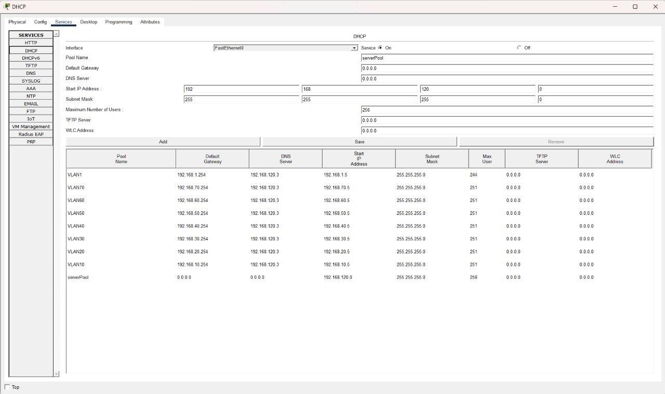

\

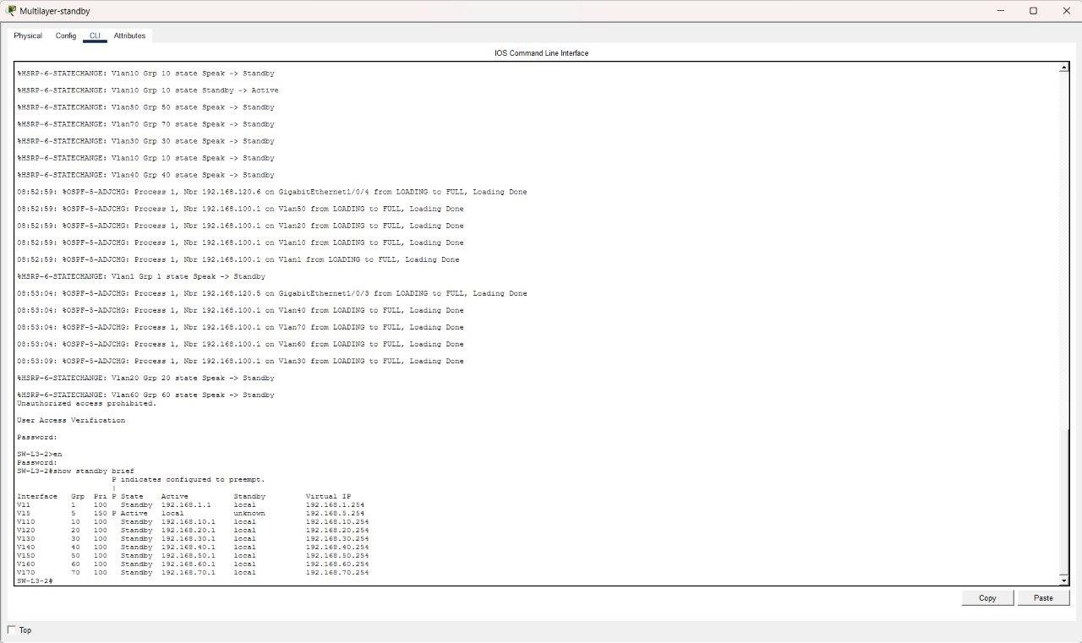

2

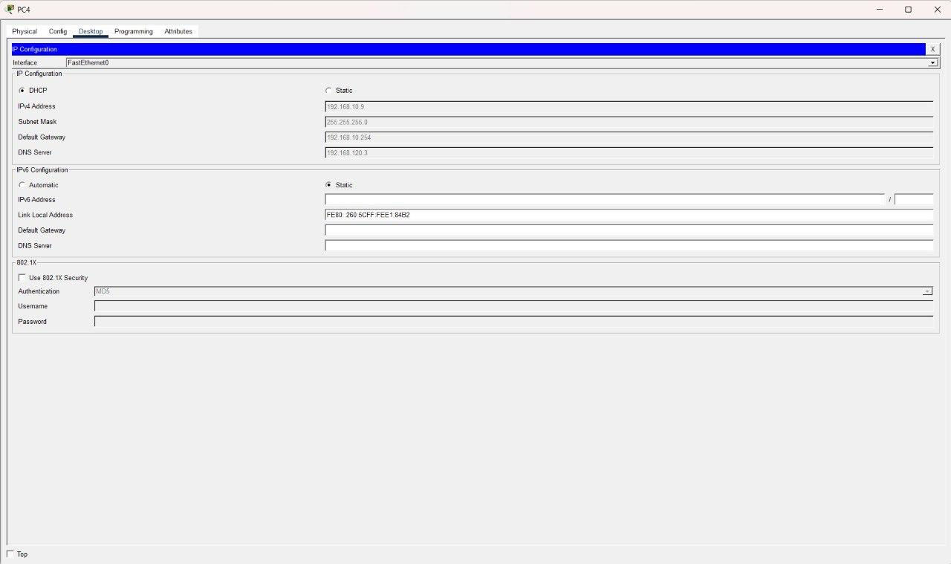

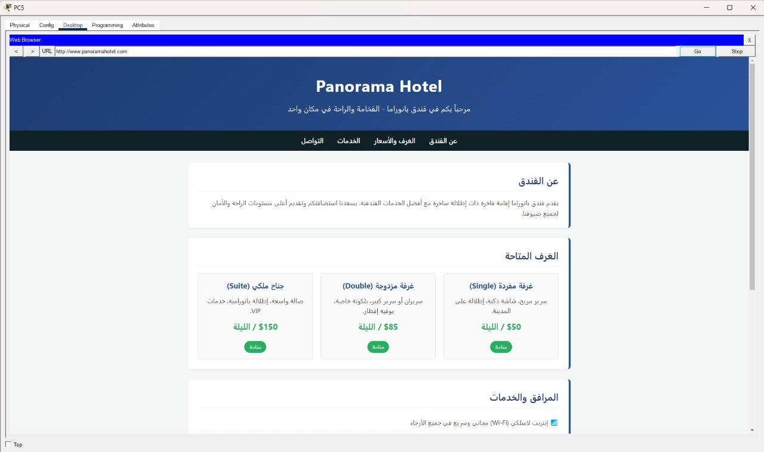

1

